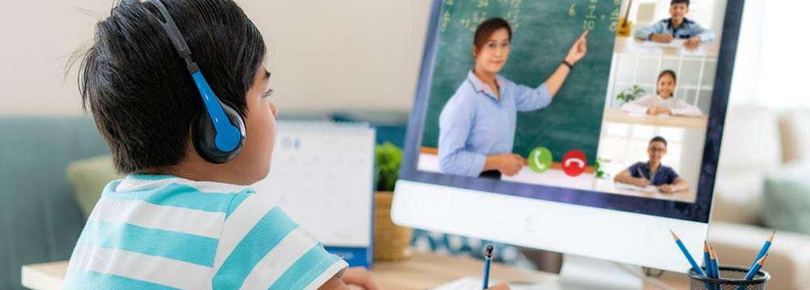
The Greenbush Virtual Academy
Eighty nine local school districts have partnered with Greenbush and their new Virtual Academy to provide virtual options for grades K-12 and adults for the 2021-2022 School Year.
The Greenbush Virtual Academy provides students a virtual option for a district’s residents. Greenbush, an experienced leader in providing virtual curriculum, will provide students access to an asynchronous platform while providing synchronous learning supports through Zoom or onsite all at no cost to student or family! This program is fully accredited, taught by highly qualified teachers for all grade levels, and is tailored to meet the local District requirements. Your student can learn at their own pace - anywhere, anytime, and will fit their specific needs.
Greenbush Virtual Academy’s Instructional Approach:
- Students grades K-5 will be enrolled in an elementary program taught by a licensed elementary teacher using the Florida Virtual School virtual curriculum platform.
- Students grades 6-12 will be taught by a licensed teacher endorsed in their specific content area. These courses will be delivered through the Edgenuity virtual curriculum platform.
- Courses are designed to meet Kansas standards and can be customized to meet any other local requirements
- Local districts establish all local requirements for credits as the credit granting institution
For further information - please contact:
Don Grosdidier at don.grosdidier @greenbush.org or (785) 979-1495

